guidance: Sensory-calming room design
What is a sensory-calming room?
Autistic colleagues and visitors will greatly benefit from being provided a private, dedicated room that is easily and discretely accessible in times when they are overwhelmed and highly anxious. Sensory-calming rooms should not only provide respite from busy and sensory intrusive environments, but importantly, somewhere where autistic people can perform calming, self-soothing and self-regulating activities away from public gaze and interruption.

Considerate design of sensory-calming spaces and rooms means that autistic people have a place that can be accessed quickly when needed and are able to spend more time and be more productive on-site after ‘re-setting.’

Can I use my existing prayer/wellbeing/nursing mothers/first-aid room?
NO: We recommend that careful consideration is given to whether the rooms proposed for sensory-calming room environments are truly sensory-neutral and private. Nursing mother rooms, first aid and prayer rooms are often occupied at certain times of the day or needed urgently by others who may disrupt a sensory-calming environment, which defeats the purpose. Intrusive (not neutral) sensory sources include (but are not limited to):

- people talking or eating
- air fresheners/soaps/cleaning products/room scents and diffusers
- bright colours and ‘fussy’ décor
- uncomfortable seating or seating too close together
- scratchy textures and fabrics
- white or high-glare (glossy) surfaces
- unpredictable ‘human’ noise
- mobile phone ring tones, alerts and vibrations
- artificial overhead lighting
- bright sunlight
- non-adjustable heating/cooling
- draughts
- heavy footfall outside
- being able to be overheard or seen when performing self-calming actions
- vibration from devices or machinery
- ‘blue’ light commonly found in white LED lamps
What are the basic elements of a GOOD sensory-calming room?
Sensory-calming rooms can be any size, or even a private work pod, but should provide enough space to lie down in comfortably. They should be sensory-neutral and afford privacy even with multiple occupants. The following sensory aspects should be non-intrusive, neutralised and eliminated.

• odours
• lighting, glints and glares
• textures
• temperature
• vibration
• external and internal noise
• colour schemes

How can we better support people to know what to expect from our space?

We recommend that clear, neurodivergent-friendly signage is designed and visible on the entrance door to your space. An example of best practice is shown below, and uses a combination of dyslexia friendly text, infographics and pictures – as well as clear guidance on how to use the room.

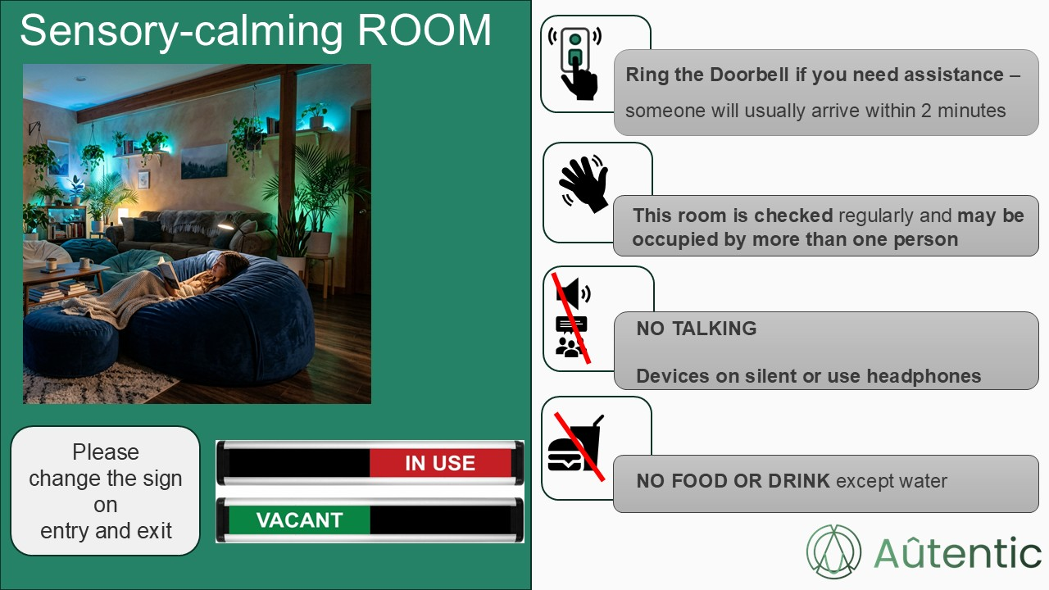

How can we better support people to navigate the space?

We recommend that a map is provided on the entrance door way, to help people navigate more quickly to the areas of the room that they may prefer, and also to locate any sensory equipment or items they may need. A best-practice example is shown below.

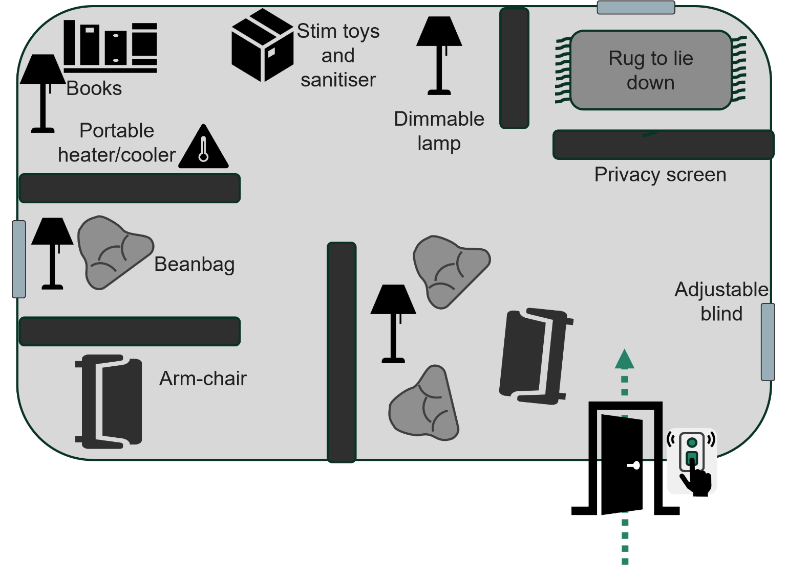

We can provide a risk assessment for you, and advise on retrofitting existing spaces to a quiet room: email info@autentic.uk

Our best-practice tips for designing an effective sensory-calming space, without us follow..

- The walls and doors of well-designed sensory-calming rooms should be opaque (not able to see through at all).

- Windows should be furnished with adjustable screens or blinds.

- Equipment should be provided to adjust the temperature quickly as needed.

- We recommend that only ‘warm’ light lamps are used in any lighting and that the lighting is dimmable.

- Rooms should not be accessed by anyone who does not need to use them, so that they are available for those that need them as ‘instantly’ as possible and without challenge.

- We recommend as a guide that one quiet room is provided per 100 people, or alternatively there should be at least one quiet room on each floor of a building. This allows people to quickly move either one floor above or below if the quiet room on their current floor is occupied and they are seeking complete privacy.

- Rooms should be provided with obvious ‘occupied/vacant’ signage on the door, so that people who are unable to share can find an alternative space without having to enter.

- Comfortable seating should be provided and enough space to lie down on the floor when needed.

- We recommend carpeting the floor, which helps with absorbing sound and also provides a soft surface to lie on.

- You may want to add soft furnishings, oversized pillows with soft textures and throws for comfort.

- You should risk assess your quiet room for hazards such as cross contamination of virus’ and bacteria that could cause illness and prepare a robust inspection and cleaning schedule.

- You may also like to provide sensory lights and sounds that can be switched off or on depending on the user’s particular needs and preferences.

- Finally, we recommend that if you are providing any fidget items, that they do not have any porous surfaces and can be sanitised with alcohol wipes before use.

